EXPLORING
THE
WORLD

Unlock a dream at iCashRewards

Disclaimer
This white paper has been prepared by Digital One Asset Foundation Ltd. (“iCash” or “iCashRewards” or “ iCash Loyalty“ or “iCashToken or the “Company”). It does not purport to contain all the information that a prospective investor may require in connection with any potential investment in the Company. You should not treat the contents of this white paper, or any information provided in connection with it, as financial advice, financial product advice or advice relating to legal, taxation or investment matters. This white paper does not include all available information in relation to the business, operations, affairs, financial position or prospects of the Company. No representation or warranty (whether expressed or implied) is made by the Company or any of its shareholders, directors, officers, advisers, agents or employees as to the accuracy, completeness or reasonableness of the information, statements, opinions or matters (expressed or implied) arising out of, contained in or derived from this white paper or provided in connection with it, or any omission from this white paper, nor as to the attainability of any estimates, forecasts or projections set out in this white paper. This white paper is provided expressly on the basis that you will carry out your own independent inquiries into the matters contained in the white paper and make your own independent decisions about the business, operations, affairs, financial position or prospects of the Company. The Company reserves the right to update, amend or supplement the information contained in this white paper at any time in its absolute discretion (without incurring any obligation to do so) without any obligation to advise you of any such update, amendment or supplement. The delivery of this presentation shall not, under any circumstance, create any implication that there has been no change in the business, operations, affairs, financial position or prospects of the Company or that information contained herein is correct after the date of this white paper. Neither the Company nor any of its shareholders, directors, officers, advisors, agents or employees take any responsibility for, or will accept any liability whether direct or indirect, express or implied, contractual, tortuous, statutory or otherwise, in respect of the accuracy or completeness of the information contained in this white paper, for any errors, omissions or misstatements in or from this white paper or for any loss howsoever arising from the use of this white paper. Any such responsibility or liability is, to the maximum extent permitted by law, expressly disclaimed and excluded. This white paper does not constitute, or form part of, any offer or invitation to sell or issue, or any solicitation of any offer to subscribe for or purchase, any securities of the Company, nor shall it form the basis of or be relied upon in connection with, or act as any inducement to enter into, any contract or commitment whatsoever with respect to such securities. Under no circumstances should this white paper be construed as a prospectus, advertisement or public offering of securities.
FUTURE MATTERS This white paper contains reference to certain intentions, expectations, future plans, strategies and prospects of the Company. Those intentions, expectations, future plans, strategies and prospects may or may not be achieved. They are based on certain assumptions, which may not be met or on which views may differ and may be affected by known and unknown risks. The performance and operations of the Company may be influenced by a number of factors, many of which are outside the control of the Company. No representation or warranty, express or implied, is made by the Company, or any of its shareholders, directors, officers, advisers, agents or employees that any intentions, expectations or plans will be achieved either totally or partially or that any particular rate of return will be achieved. Given the risks and uncertainties that may cause the Company’s actual future results, performance or achievements to be materially different from those expected, planned or intended, you should not place undue reliance on these intentions, expectations, future plans, strategies and prospects. The Company does not represent or warrant that the actual results, performance or achievements will be as intended, expected or planned.
CONFIDENTIALITY Your receipt of this white paper constitutes your agreement, on behalf of yourself and your representatives, to maintain the confidentiality of the information contained in this white paper. Other than upon prior approval by the Company, any reproduction or distribution of this white paper in whole or in part, any disclosure of its contents or any use of any information contained in this white paper for any purpose is strictly prohibited.

Table of Contents

Our Mission 4
Our Inspiration 4
Introduction of iCashRewards 5
Background of Blockchain Loyalty 5
The Opportunity and Challenge 7
Business Model 8
iCashReward Ecosystem System 8
Loyalty Rewards Merchants 12
Redeem iCash Loyality Points 14
What’s Next for iCashRewards? 15
Team 17
iCash Loyalty Structure 20
Milestones and Community Support 21
Roadmap 23
Use of Proceeds 24
References and Media 25
Corporate News 26
References 27
Contact Us 29

Our Mission

A powerful infrastructure for tokenization development and traditional loyalty rewards which empowers billions of people during digital transactions.

- Reinvent loyalty rewards.
- Transform the global economy.

Our Inspiration
According to our advisor, Philip Shelper, author of “Blockchain Loyalty: Disrupting Loyalty and Reinventing Marketing Using Cryptocurrencies, there are six elements in a successful loyalty program. The main purpose is to build customer loyalty and generate repeat business.

SIMPLE | EMOTIONAL | VALUABLE
It must be easy for the user to join, understand and engage in a loyalty program. | Personalized service and social inclusion invoke an emotional response from users. | Popularity and incentives increase the perceived value of a loyalty program.
SUPRISING | DIFFERENTIATING | DEVELOPING
Unexpected and delightful small wins increase the satisfaction of users, which increases the loyalty of users to the brand. | The current market gives crypto tokens a momentum to stand out and differ from other loyalty programs. | Using trials and user feedback will keep the loyalty program continuously engaging and enhanced for users.

Introduction of iCashRewards
A Trusted Partner in Blockchain Loyalty

The world needs a reliable blockchain loyalty program. Securing loyalty points should be as easy as sending a text or sharing a photo as long as the user has a connection to the Internet. The iCashRewards is made up of three parts that will work together to create a more inclusive loyalty program. This document outlines our plans for a new blockchain loyalty and a smart contract platform that together aim to create a new opportunity for responsible customer loyalty innovation.

iCashRewards, a Digital One Network Business, is a leading provider of digital rewards solution to merchants and consumers across the globe. iCashRewards is reinventing marketing using blockchain technology for loyalty rewards, supporting digital rewards program and powered by tokenized technology to disrupt loyalty industries and continuously innovate.

iCash will reward users with iCash Loyalty Points, which were tokenized on the Ethereum Blockchain Network. iCash has been launched on the blockchain ecosystem of IOST, KCash, ZOS, Pundi X, iBOFi, iBankEx, XPass and XPOS, Digital One Asset Foundation, iBank Digital Asset and Cao Jun Art Institute.

iCashRewards is governed by Digital One Asset Foundation Ltd. (“Digital One Foundation”) which is an independent, not-for-profit membership organization incorporated in Singapore. iCashRewards in Canada is operated by Digital One Asset Corp. located in Vancouver.

Background of Blockchain Loyalty

Limited Utility
Philip Shelper, the author of ‘Blockchain Loyalty: Disrupting loyalty and reinventing marketing using cryptocurrencies’ states that, most traditional loyalty programs only allow points to be used within their own ecosystem such as using it for making purchase in-person, online store or other discount promotion. Converting loyalty points to cryptocurrencies would allow members to exchange their points for other cryptocurrencies or even fiat currency depending the user’s local law requirement for exchanging crypto to fiat.

Points Expiry
Members who aren’t frequent users of the loyalty program may find that their points are expired due to activity time restrictions. For instance, if no points are earned or redeemed within a certain time frame, the account balance may be reduced to zero. Large loyalty rewards programs deliberately manage their users with time frame restrictions in order to maximize their program profitability.

The use of crypto loyalty avoids these issues since they don’t expire. It is beneficial the users and members since the loyalty program operator can’t rely on controlling the program to maximize profits.

Systematic Devaluation
Airline companies in the past have adjusted their loyalty rewards programs to favor their profitability. The reward system and points lose value over time and devalued by the airline to generate more profit from the program. This increase of the cost of points penalizes loyal customers and those who have many points saved up in their balance.

The decentralization of cryptocurrencies causes the value to fluctuate principally on market forces. The cryptocurrencies within the loyalty programs are actively being traded on digital exchanges. The loyalty program operator is unable to adjust the prices to boost profitability as the control over values is determined by the market price.

General Disillusion
Analytics indicate that members disengage from loyalty programs because the value added does not generate enough brand loyalty. Cryptocurrencies have the ability and potential to deliver more value than miles and points because of its flexibility and fluidity. Cryptocurrencies can increase in value during periods of higher demand. Since the supply pool of currencies is finite, the demand will match and gauge interest.

Saturation and Homogenisation
Currently, many loyalty programs exist, and they are all conglomerated into irrelevance because of the redundancy rewards to loyalty ratios. In order to stand out and to generate value for consumer interest, blockchain loyalty creates the opportunity for early adopters to create a different approach to loyalty programs. Blockchain loyalty currencies changes in value, never expires and exists as a sharp contrast to traditional points and miles systems of today.

Marketing assault
Traditional loyalty rewards users are bombarded with email promotions which advertise products that they don’t want. Through the new innovation of blockchain marketing, members have full transparency over their data with a secure, blockchain-hosted data wallet which holds their private key. The reasoning behind this approach is to innovate new forms of marketing on a global scale which utilizes the core design of loyalty programs while controlling and protecting the privacy of personal data (Shelper P., 2018).

As with any disruptive innovation, retailers and loyalty program operators will have reservations when it comes to adopting and utilizing crypto tokens as part of the new design of loyalty rewards. There are currently three factors that create the stigma attached with cryptocurrency transactions,
- Crypto token price fluctuations
- Adjustment required to the marketing approach.
- Stigma attached to cryptocurrency

Source:

Shelper P. (June 6, 2018) Blockchain Loyalty: Disrupting loyalty and reinventing marketing using cryptocurrencies

The Opportunity and Challenge

While cryptocurrency has been around for over 10 years, it is still exciting to many new users who do not own any or only owns one type of cryptocurrency. The introduction of a loyalty program that rewards users with various cryptocurrencies exposes users to a fun and exciting market. Rather than receiving points, users are receiving actual currency with value that has a chance to grow. Their exposure to different cryptocurrencies without actually “purchasing” it allows them to experiment and try out the crypto market more than they previously would do.

As we explore the opportunity together, we believe it is important to share our beliefs to align the community collective understanding of Blockchain loyalty program:

- We believe that loyalty points should be transferable to other members and convertible to other digital assets;
- We believe people have the right to control the loyalty points that they earned;
- We believe that blockchain loyalty programs will create enormous economic opportunity and more consumer activities across the world;
- We believe people will increasing trust decentralized network governance;
- We believe that we all have the power to advance the loyalty system, encourage good behaviors and progressively uphold the trustworthiness of the blockchain loyalty programs.

Business Model
Spend, Earn and Convert with Ease

iCashRewards is reinventing marketing using blockchain and cryptocurrencies for the tokenized economy and decentralized finance ecosystem.

iCashRewards is focused on enterprises blockchain loyalty program and is dedicated to tap into enterprises communities to act as a recruiter for retailers and members.

Users within the iCashRewards ecosystem will be able to earn iCash loyalty points for the spending you do everyday. Users can redeem points for e-gift cards bitcoin gift card, and prepaid card. Users shall enjoy exclusive offers from our merchants, receive rebates and discount through its promotion programs.

iCashRewards Basic Functions

Service Fee Rebate/ Discount | Project Party’s Participation | Project Party Rewards | Future Retail Service
iCash holders will receive commission rebates which result in a discount on transaction fees for using services in our ecosystem | Allowing project party to utilize iCash through their rewards promotion plan | iCash holders will receive loyalty rewards from merchants | iCash holders will be able to make purchases and receive credit through our ecosystem

iCashReward Ecosystem System

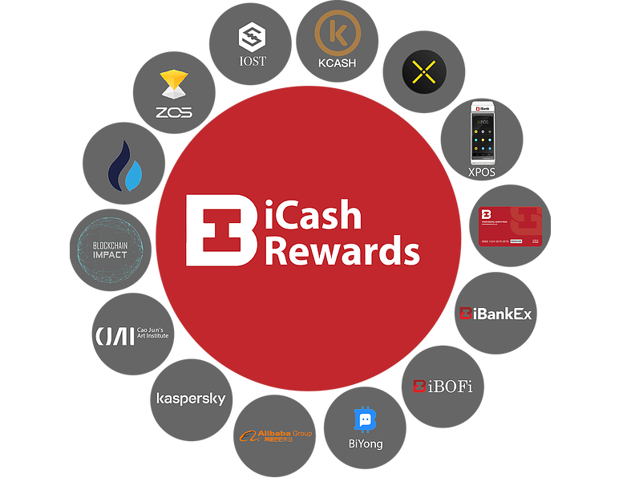

IOST – Unleashing the Power of Blockchain

IOST is an ultra-fast, decentralised blockchain network based on the next-generation consensus algorithm “Proof of Believability” (PoB). Led by a team of proven founders and backed by world-class investors, our mission is to be the underlying architecture for online services that meets the security and scalability needs of a decentralized economy.

iCashRewards have worked with IOST to roll out rewards promotion programs. iCashRewards is committed to promoting the IOST network and Blockchain development towards the advancement of global communities.

KCash – Future Digital Bank ALL IN ONE

KCash supports iCash to convert ETH.
Kcash is a decentralized digital wallet supporting multiple blockchain assets. It allows you to store, send and receive blockchain assets safely and gives you 100% control of your assets.

iCashRewards will work with KCash to roll out rewards promotion programs.
Users are able to use most of the functions that is offered by KCash wallet including but not limit to giving crypto (Red Packet), daily candy and loan functions.

PundiX - Use digital currencies anytime, anywhere.

Pundi X is a leading developer of blockchain-powered devices which include the XPOS, the world’s first point-of-sale solution that enables merchants and consumers to conduct in-store transactions instantly on the blockchain. The XPOS solution has been shipped to over 25 markets including Argentina, Australia, Colombia, Korea, Singapore, Spain, Taiwan and the USA. 100,000 XPOS devices are being targeted to roll out globally by 2021.

iCashRewards have worked with Pundi X to roll out rewards promotion programs. iCashRewards is seeking listing on the Pundi X platform. Users will be able to use Xpass to make purchases or receive credit using digital currencies anytime, anywhere with the iBank Stablecoin XPOS device that is powered by Pundi X.

ZOS – A Compliant Global Crypto-backed Lending Platform

ZOS is a public chain providing smart financial services, aims to build a blockchain financial open system worldwide. ZOS connect crypto asset and fiat asset by providing the blockchain infrastructure and builds a new financial system including the issuing/investment, trading, and lending of crypto assets.

iCashRewards will work with ZOS to roll out rewards promotion programs.

iBOFi – A Trusted Partner in Decentralized Crypto-Fiat Lending

iBOFi, A Decentralized Global Lending Network powered by ZOS network. iBOFi supports cash loans in Canadian dollars and Stablecoin USDT to individuals and use Bitcoin and Ethereum as collateral. iBOFi has received a lending business license and it is registered as MSB with FINTRAC.

iCashRewards will work with iBOFi to roll out rewards promotion programs. iCashRewards holders can currently receive rebate on iBOFi transaction fees.

iBankEx – A Trusted Partner in Loyalty Exchange, A Global Rewards Network

iBankEx, is a leading loyalty exchange and rewards platform for projects and connecting with investors and users supported by Huobi Cloud Technology. iBankEX have established an efficient fiat to crypto trading platform that is registered with FINTRAC in Canada. www.ibankex.io

iCashRewards have worked with iBankEx to roll out rewards promotion programs. iCashRewards is seeking to listing on iBankEx to increase liquidity for its holders. iCashrewards holder can currently receive rebate on iBankEx transaction fees.

iBankDigital – “A Trusted Partners in Digital Assets Service”

iBank Digital Asset L.P. (“iBank Digital”), based in Vancouver, Canada, is a leading provider of crypto trading platforms, supported by Huobi Cloud, and lending through the world's first decentralized global network.

iCashRewards will work with iBank Digital to roll out rewards promotion programs.

Huobi Cloud– “The Leading Global Digital Asset Exchange Since 2013”

Huobi Global is a world-leading cryptocurrency financial services group. In 2013, the founding team foresaw the great potential of the blockchain industry to revolutionize the future of the global financial system. The Huobi team is dedicated to providing safe, professional, trustworthy, and world class services to its global clients in an effort to create a client first culture. Huobi Global has planted offices in Singapore, the United States, Japan, Korea, Hong Kong, and is prevalent in over 130 countries across the globe.

Blockchain Impact – “Brings together GPs and LPs in Blockchain technology and investment”

The Blockchain Impact Institute founded in Vancouver, British Columbia by experienced professionals with buyside and sellside expertise, is a dynamic platform designed to introduce the latest in distributed ledger or blockchain technology and its related applications to investment professionals across the globe from private equity, venture capital, family offices and institutional investors.

iCashRewards have worked with Blockchain Impact to roll out rewards promotion programs.

Loyalty Rewards Merchants

Consumers can earn iCash rewards shopping at their favorite store.

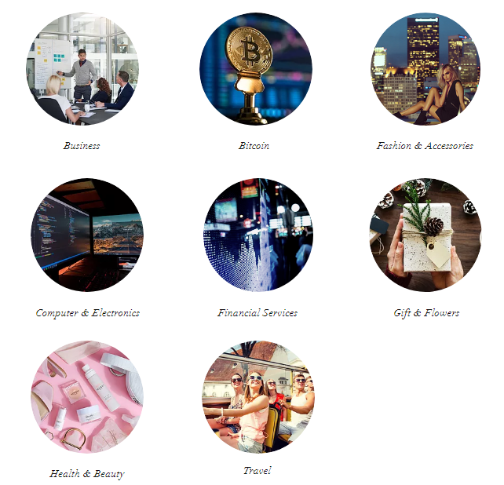

Current merchants accepting iCashRewards loyalty program includes the following:

Business | Alibaba, Shippo, iBank Stablecoin XPOS
Bitcoin | Buy BTC with Credit Card, Buy BTC with e-Transfer
Fashion & Accessories | SSENSE, Lacoste, New Balance, Fossil, LXRandCo, Shoptiques
Computer & Electronics | TurboTax, Kaspersky, Godaddy, Microsoft, Dyson
Financial Services | iBank Xpass, iBankEx, iBOFi
Gift and Flowers | Cao Jun Gift Card, iCash Individual Package
Health and Beauty | Foreo, PerfectLensWorld, Boost Oxygen
Travel | Cheap0air, BookingBuddy

 |  | 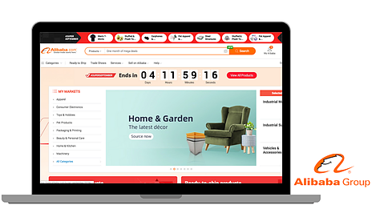
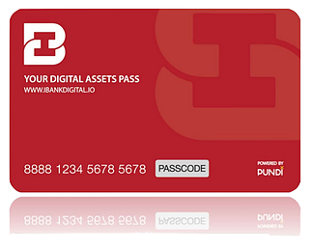 | 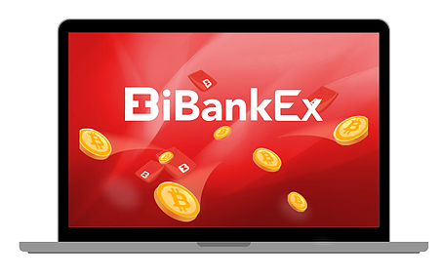 | 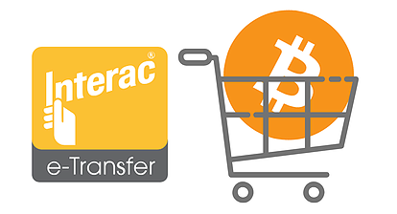
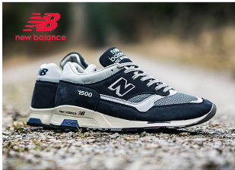 |  | 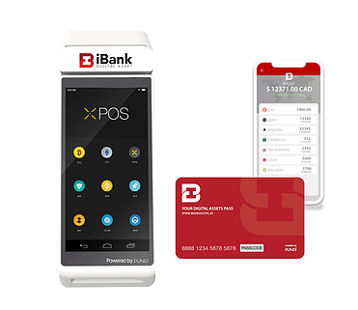
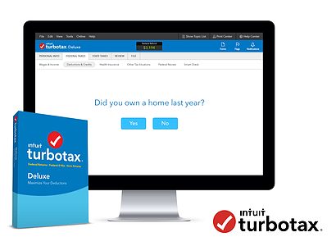 | 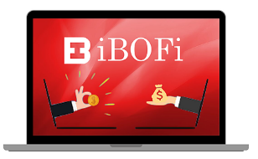 | 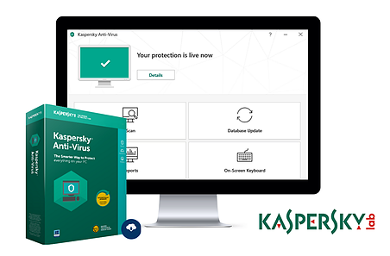
 | 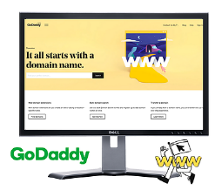 | 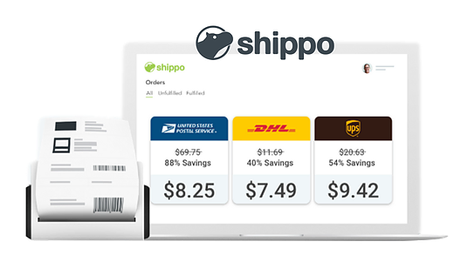

Redeem iCash Loyality Points

iCashRewards holders can redeem iCash with most commonly use cypto tokens, most commonly use gift cards or prepay master card.

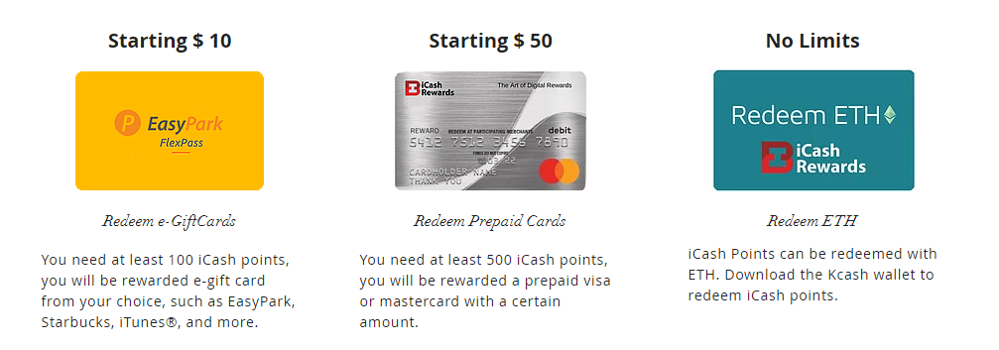

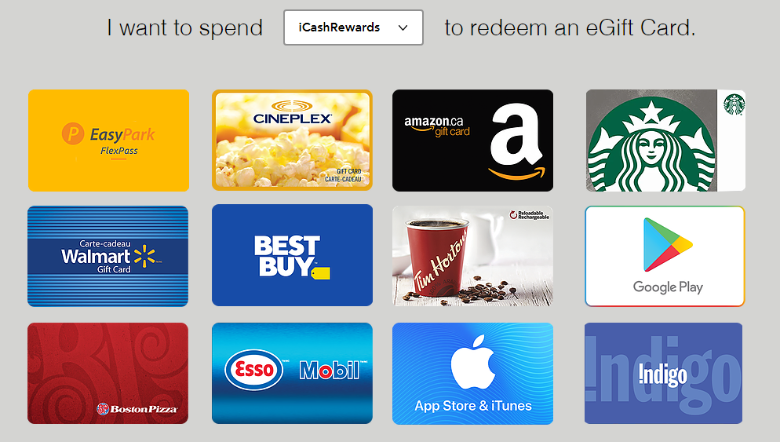

What’s Next for iCashRewards?

Mobile Solution

We will contine to connect our full suite of service with other service providers to broden our userbase. We are developing to create a easy to use wallet that allows users to convert triditional loyality points to iCashRewards and vice versa. Our users will be able to convert, earn and spend with iCash with ease.

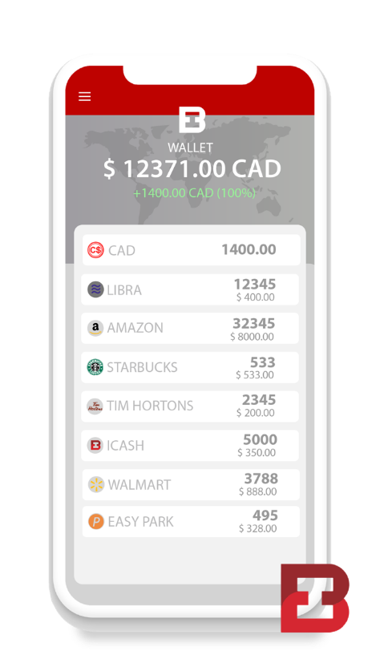 | 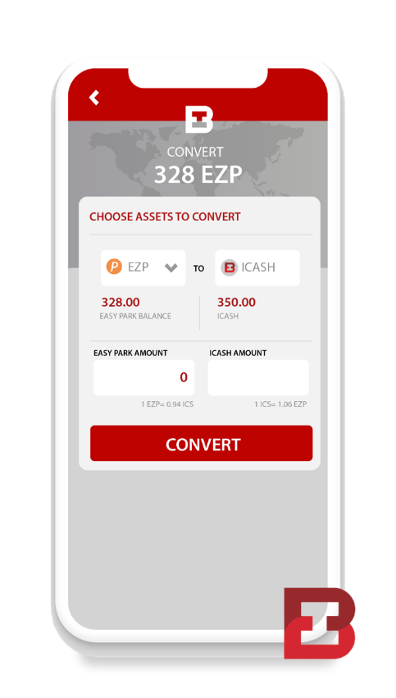 | 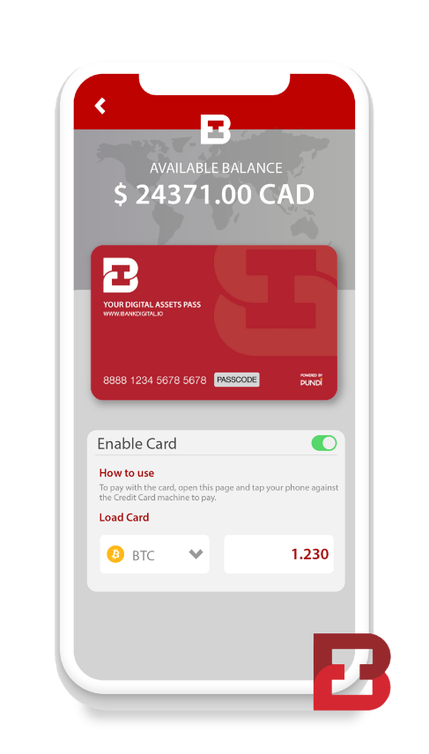
All your Points in one place | Convert to Cash or other points | Spend you points

Enterprise Solution Development

Easy Park – We are modern, innovative, and constantly upgrading

EasyPark has a service history of over 70 years in parking management and excellence within the City of Vancouver. EasyPark’s operations have grown to encompass more than 125 parking facilities in over 60 diverse client accounts.

iCashRewards will work with Easy Park to roll out rewards promotion programs.

Cao Jun’s Art Institute – Nature and humanity can co-exist harmoniously

Cao Jun’s artwork has been featured in exhibitions at the National Art Museum of China, McMullen Museum of Art at Boston College and Long Island Museum in New York and more.

Cao Jun’s Art Institute, iBank Digital and XPass have collaborated to create the world’s first limited edition of Cao Jun gift cards. Cao Juan museum in Beijing, Xian, Shenshen and New York is planning to accept Bitcoin payment and iCasRewards as their loyalty

MLG Blockchain – Turnkey Execution with Global Distribution

MLG Blockchain is a global venture creation and capital advisory firm with blockchain technology development and broker dealer capabilities. Headquartered in Toronto and New York City with a distributed team across 20+ countries, MLG Blockchain offers premium blockchain consulting services, with both regional and global representation for clients around the world.

MLG Blockchain accepts iCashRewards as payment for their advisory services.

Ammolite Museum

Ammolite Museum is proud to be the largest authorized retailer for Korite International in the Greater Vancouver area, providing the opportunity for tourists and locals to come learn and appreciate this national treasure of Canada.

iCashRewards have worked with Ammolite Museum to roll out rewards promotion programs.

Team

Min Kuang - Founder
Min Kuang has over 20 years of experience in international finance, structuring capital investments, mergers and acquisitions and business development in the consumer, fintech and healthcare industries.

Linkedin: http://bit.ly/MinKuang

Steven Shen - Founder
Steven Shen has more than 15 years experience in the real estate sector. He was one on the initial investor of Digital One . He has been actively involved in fund raising for SUCCESS BC, a non-profit organization in Canada.

Alvin Zhao – Director
Alvin Zhao is an Information Technology Leader with extensive experience in design, development, implementation and management of business applications, operational database and data warehouse systems including end-to-end process for applications, data warehouse and business intelligence projects.

Linkedin: http://bit.ly/AlvinZhao

David Yoo – Director
David Yoo is an experienced Chief Financial Officer with a demonstrated history of working in the investment management industry. Skilled in Investor Relations, Venture Capital, Equities, Private Equity, and Corporate Finance. Strong business development professional with a MBA focused in Finance, Accounting from New York University, Stern School of Business.

Linkedin: http://bit.ly/DavidYoo

Michael Gord – Director
Michael Gord is an entrepreneur focused on changing the world by building next generation decentralized applications using blockchains and smart contract technology.

Linkedin: http://bit.ly/MichaelGord

Nick Mellios - Director
Nick Mellios is an Information Technology Leader with extensive experience in blockchain, back-office transactions management, boftware encryption, digital rights management-commerce, computer networking, games development

Linkedin: http://bit.ly/NickMellios

Blair Lowther - Director
Blair Lowther is an experienced lawyer, director and lecturer with a demonstrated history of working in the general business, blockchain, sports and cannabis industries. Skilled in business development, legal compliance and transactional matters. Holds a Bachelor of Arts (BA) and Doctor of Law (JD) from The University of British Columbia.

Linkedin: http://bit.ly/BlairLowther

Simon Cheng – Managing Director
Simon Cheng is a Certified Bitcoin Professional. He has over 10 years of experience in the capital market sector. His focus at iCashRewards is on project management, with an emphasis on business development, partnership negotiations and decentralized finance.

Linkedin: http://bit.ly/SimonCheng

Fanny (Ly) Travis - Director of Business Development
Fanny Travis has over 10 years on experience in business development. Her focus at iCashRewards is on client management, with a focus on social media, event and community development.

Linkedin: http://bit.ly/FannyTravis

Emily Li - Director of Marketing
Emily Li has over 5 years of marketing experience with emphasis on curating marketing content, collaborating with channel partners, enforcing content guidelines and developing editorial content on website and social media.

http://bit.ly/EmilyLi

Geoffrey O – Director of UX/UI and Design

Geoffrey has over 3 years of UX/UI design and Graphics Design. His focus at iCashRewards is to design innovative UI/UX designs that create lasting impressions which allows businesses retain customer and brand loyalty.

Joy Huang – Creative Manager

Joy Huang has over 5 years of experience as a creative manager. She designs iCashRewards branding, communication and social presences. She oversees integrated advertising campaigns across multiple media channels and delivers strategic creative that successfully achieves business goals.

Philip Shelper – Advisor

Philip Shelper loyalty and reward leader with extensive experience in management consulting, loyalty programs and psychology. He is the author of 'Blockchain Loyalty: Disrupting Loyalty and Reinventing Marketing Using Cryptocurrencies.'The world's first book on blockchain loyalty.

Linkedin: http://bit.ly/PhilipShelper

Tracy Leparulo – Advisor

Tracy Leparulo is a business leader who focuses on blockchain event management. She is the founder for Untraceable which is the first event management and marketing agency within the blockchain and cryptocurrency community in Canada.

http://bit.ly/TracyLeparulo

Manie Eagar – Advisor
Manie Eager is a business leader who focuses on innovations in rapid technology inventions and convergence continue to evolve and accelerate “techno-forming” the world. Manie has International track record in banking (Barclays/ABSA), IT/telecommunications (Dimension Data & Vodafone), investment management (J&J Group/Old Mutual), and a director of the Bitcoin Alliance of Canada.

LinkedIn: http://bit.ly/ManieEagar

iCash Loyalty Structure

Total tokenized Loyalty Points: 300 million

The table below include 100 million loyalty points for our strategic partners merchants.

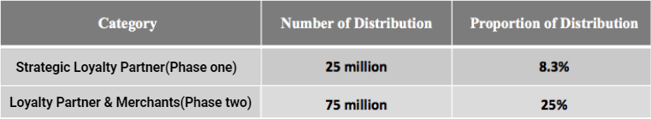

The table below includes 200 tokenized Loyalty Points, 50 million loyalty rewards to core team will be lock up 1 year upon conversion launched.

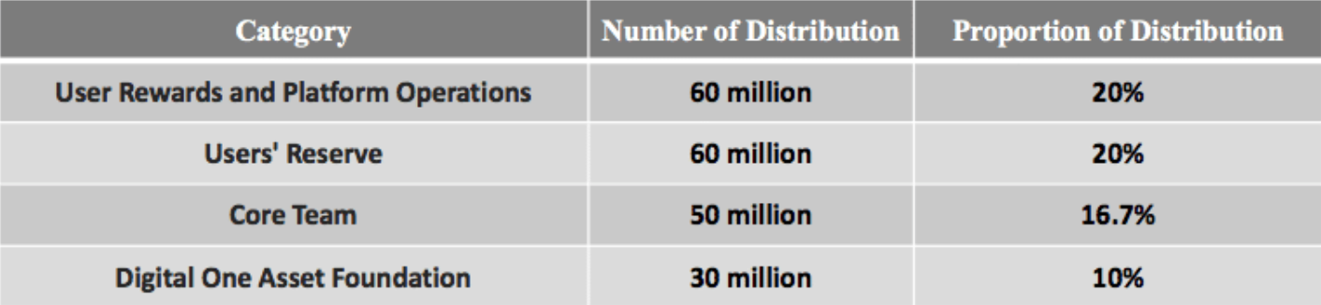

Milestones and Community Support

iCashReward X iBankEx collaboration

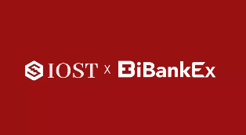 | iCashRewards successfully appointed as exclusive loyalty rewards operator for IOST token and iBankEx as Global Node Partner.
 | iCashRwards successfully sings strategic partnership with Pundi and XPOS to enter in Canadian Market. We contributed our rewards through iBank XPass to the Rotary Club during Chinese New Year Charity Luncheon
 | iCashRewards and Rotary Club jointly supported the 2019 SUCCESS Gala. More than 800 philanthropists attended the event and raised over $500k CAD.
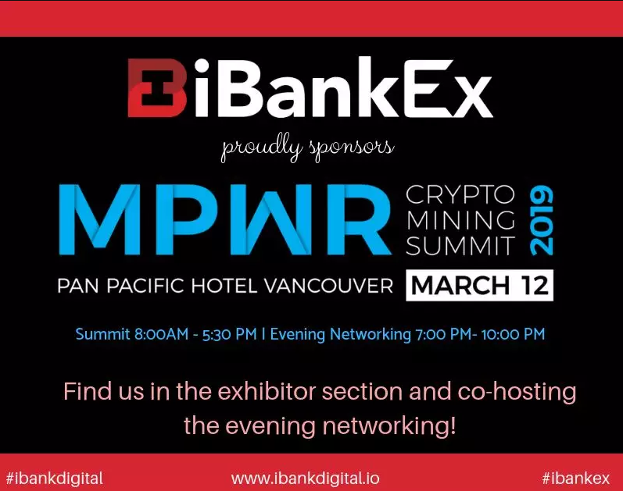 | iCashRewads contributed rewards through iBank Xpass and jointly sponsor MPWR Encryption Mining Summit.
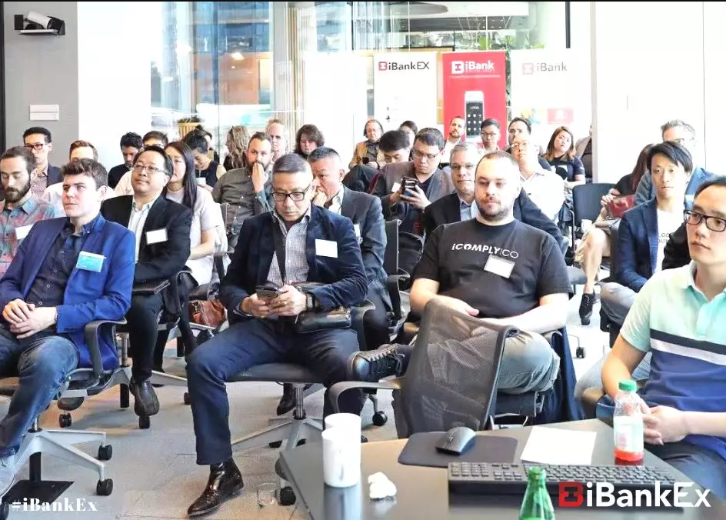 | iCashRewads contributed rewards through iBank Xpass and jointly supports the Vancouver Blockchain Impact Appreciation Conference
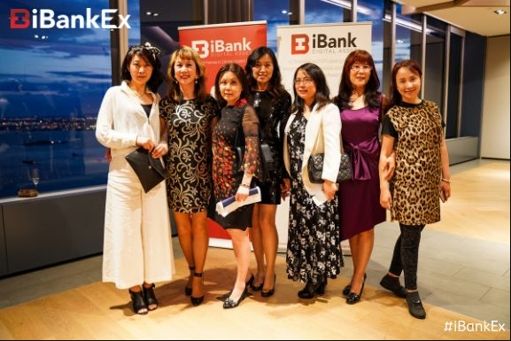 | iCashRewads contributed rewards through iBank Xpass and jointly supports Blockchain Impact New York's Consensus — “A Night at Blockchain Impact” cocktail party.
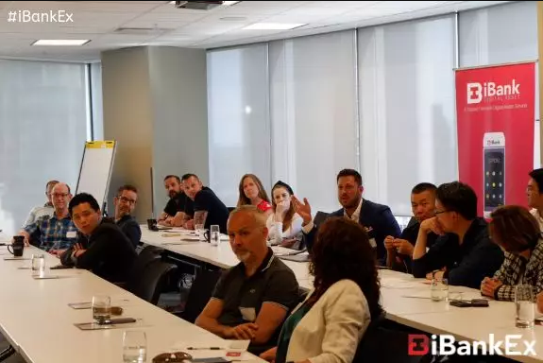 | iCashRewads contributed rewards through iBank Xpass and jointly participates in the CBD Cannabis Roundtable Seminar organized by Blockchain Impact
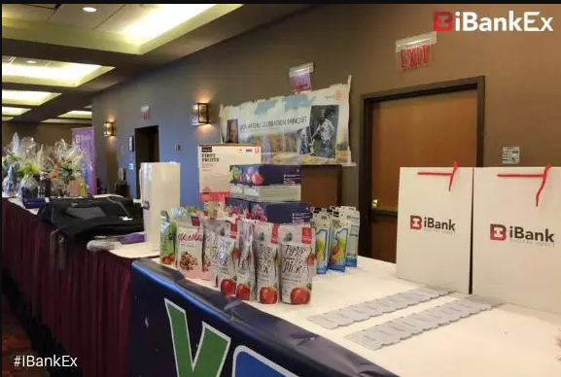 | iCashRewads contributed rewards through iBank Xpass and jointly sponsor The 35th "Bicycle Marathon" of Vancouver Rotary Club sponsored by iBankEx. 156 cyclist participated and raised over $150K CAD.
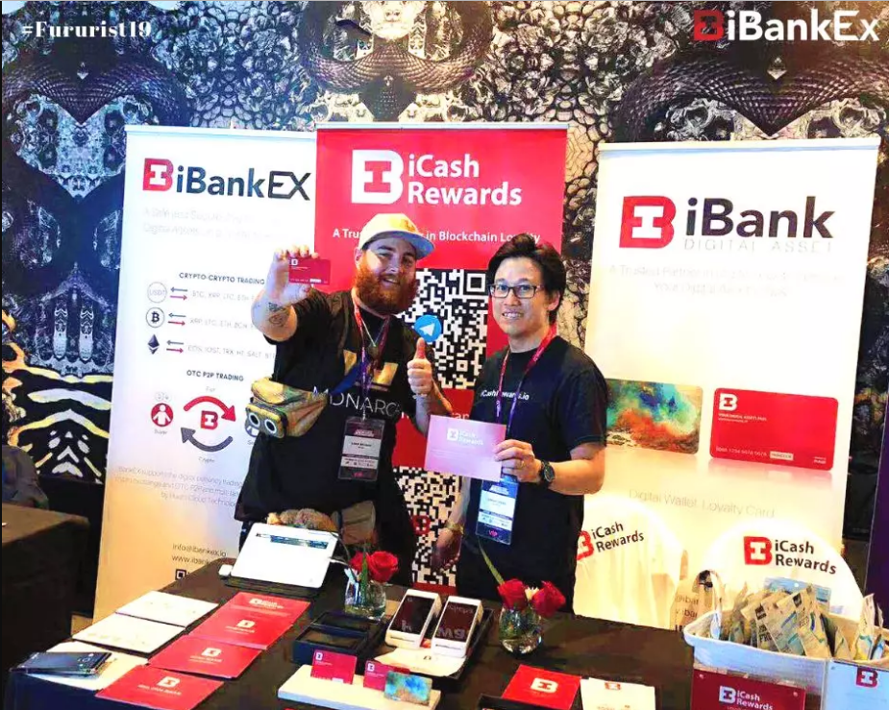 | iCashRewads contributed rewards through iBank Xpass and jointly Sponsors Toronto Futurist Conference. During the conference , we featured iBank Global Limited-Edition Digital Wallet that is commissioned by world-renowned artist Cao Jun, assisted by public chain IOST.
Other sponsored events and meet ups

After half a year of user acquisition activities, community service promotion and participation in blockchain conferences, iCashRewards' ecosystem including iBank Digital, iBoFi, and iBankEx, have accumulated more than 12,000 registered users as of August 2019.

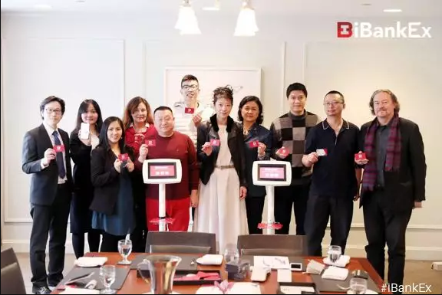
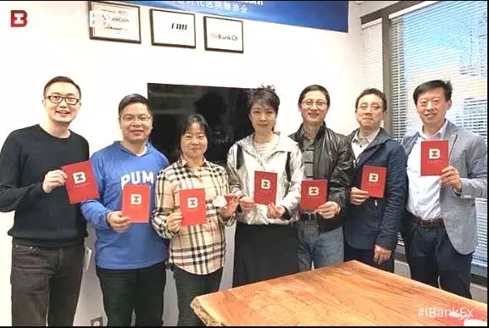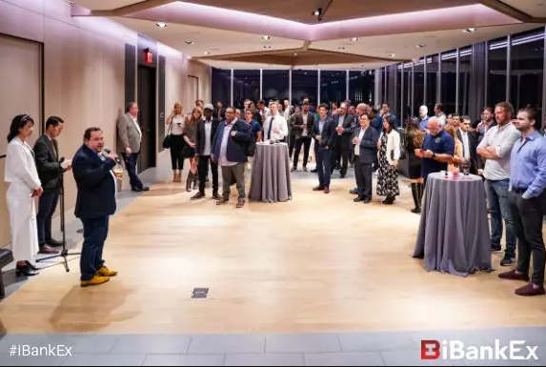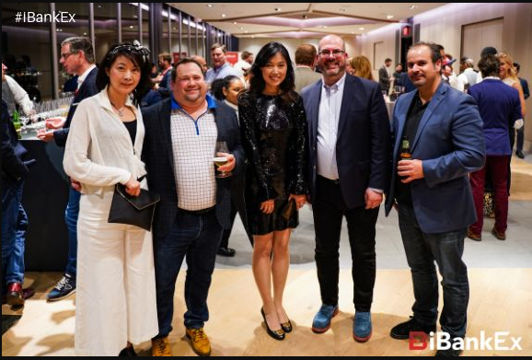

Roadmap

Q4 2019 -  Business Development | Launch reward promotion with iBOFi. iBOFi, A Decentralized Global Lending Network powered by ZOS network. iBOFi supports cash loans in Canadian dollars and Stablecoin USDT to individuals and use Bitcoin and Ethereum as collateral. iBOFi has received a lending business license and it is registered as MSB with FINTRAC.
 | Complete enterprise solution for Easy Park. EasyPark has a service history of over 70 years in parking management and excellence within the City of Vancouver. EasyPark’s operations have grown to encompass more than 125 parking facilities in over 60 diverse client accounts.
 | Develop rewards project for IOST. IOST is an ultra-fast, decentralised blockchain network based on the next-generation consensus algorithm “Proof of Believability” (PoB). Led by a team of proven founders and backed by world-class investors, our mission is to be the underlying architecture for online services that meets the security and scalability needs of a decentralized economy.
Q4 2019 –  Community Contribution | Launch reward project for Rotary Foundation and Bill Gate foundation. The Rotary consist of 1.2 million business, professional, and community leaders in more than 200 countries and geographical areas providing humanitarian service building goodwill and peace in the world.
 | Sponsor Art Umbrella Splash 2019 Event. More than 600 business and community leaders will join this event. Splash 2019 will feature 100 one-of-a-kind art works by renowned creatives including EdwardBurtynsky, Dana Claxton, Douglas Coupland, Andrew Dadson, Henri Dauman, Christos Dikeakos, Jeff Wall, Stephen Waddell, and Elizabeth Zvonar. The evening will be emceed by CBC news personalities Gloria Macarenko and Fred Lee, and co-chaired by avid arts supporters Christie Garofalo and Bruce Munro Wright.
 | Donate to the following museums:
 | Royal Academy of Arts in London
 | Musses’ Art Mideme in Paris
 | Museum of Modern Art in New York
 | Boston University Museum
 | the Palazzo Reale in Milan
 | Montreal Museum of Fine Arts

Use of Proceeds

38%
Execution
19%
Retail

$500k Retail showrooms will allow customers to experience how to make purchase, earn loyalty point and make redemption
$1m Deliver 10 loyalty program to merchants will require infrastructure, computer hardware and support

Angel Round
$2.62M

19%
Development
24%
Operation

$620k Acquire and retain talents to maintain true global competitive advantage
$500K to develop an application with continuous customer support

References and Media

Our Influence at reach through our marketing channels have over 5 million users

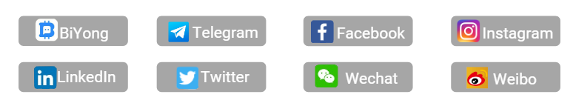

Corporate News

April 3, 2019 | The World’s First Limited Edition of Cao Jun Digital Gift Cards iBank XPass Powered by Pundi X and IOST Blockchain | https://yhoo.it/2lwSUaG
April 23, 2019 | Toronto and New York Based MLG Blockchain Accepts iCASH Loyalty Cards as Payment for Their Advisory Services | http://bit.ly/2lX474G
Sept 15, 2019 | iCashRewards Launching Red Packet Function Powered by BiYong | https://yhoo.it/2nUFh6w
Sept 25, 2019 | iCashRewards Explores use of DigitalBits Blockchain | https://yhoo.it/2mmPKXQ

References

iCashRewards mock up design for mall promotion

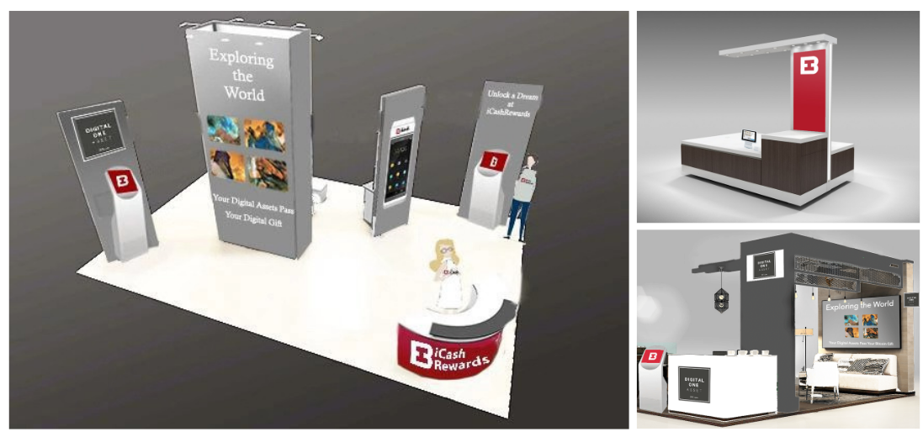

iCashRewards print marketing material
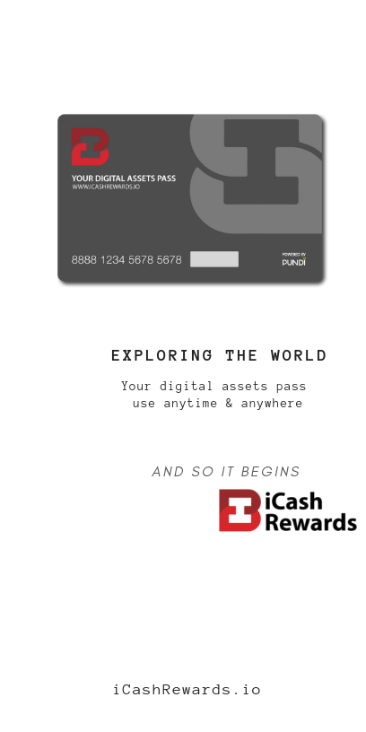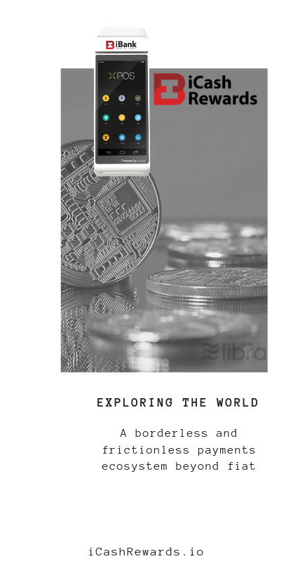

Logos

iCash, A Trusted Partner in Loyalty Rewards!

Contact Us

info@digitalone.io

